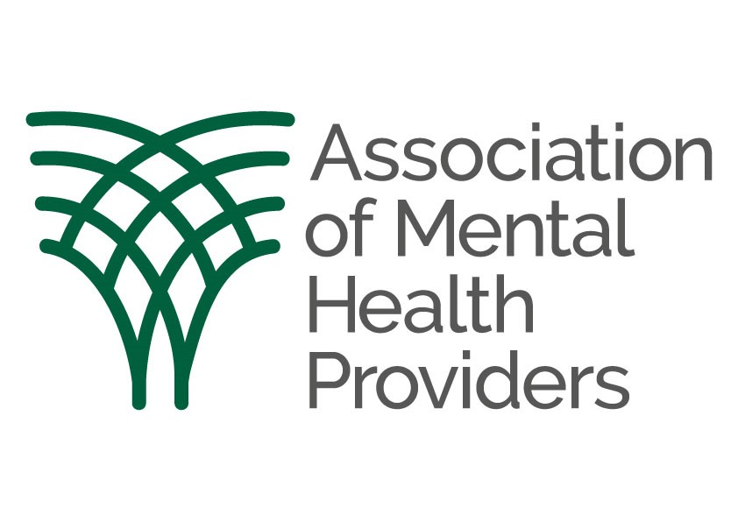

Lived Experience Advisory Group Member Application Form

Name: |  | Address:
Home Phone:
Mobile Phone:
Email:

We are looking for people with living or learnt experience of poor mental health and illness, including SMI, or an unpaid carer, who are passionate about mental health and want to make a difference. We would like you to have the capacity to effect change and have an impact on mental health policy and practice.

You will be willing to share your expertise and personal experiences, whilst being understanding and empathetic of others’ differing views and experiences. Individuals will be open to other people’s ideas and new ways of thinking and be able to communicate effectively. People who draw on services and their families and carers will be central to everything we do and if you would like to act as our critical, but constructive, friend, we look forward to hearing from you.

Please note, that you can apply to be a Lived Experience Advisory Group Member via this form or in a video telling us about yourself, both can be sent to Cheryl@amhp.org.uk

If your application is successful, your application will be kept on file during your term of office as an Advisory Group member and for 6 months after the end of your term of office.

If your application is unsuccessful, this form will be kept on file for 6 months.

GENERAL DATA PROTECTION REGULATION DECLARATION

The Association of Mental Health Providers will use the personal information you provide in this form for the purposes of administering your application to become a Lived Experience Advisory Group member.

We may share your information with current Lived Experience Advisory Group members. For more information on how we handle your personal information, please see our privacy policy at: https://amhp.org.uk/privacy-policy

I consent for The Association to share and store my personal information in accordance with the provisions of the General Data Protection Regulation.
As part of the recruitment process, we will share your application information with Group Co-Chairs and staff involved in the recruitment process. Please tick to give your consent to sharing the information you give with the group members involved in recruitment.

If you need any help competing this application, please contact Cheryl@amhp.org.uk and we will provide some support.

About you
We would like this information to make sure that we’re giving equal opportunities to all candidates and ensuring that our groups are as representative as possible. Please provide as much information as you can to help us make an informed decision.

Please add any further comments you would like to make at the end of the form.

Please tick all those that apply to you:

☐ I have previously used or am currently using services provided by the VCSE mental health sector –including community, housing, residential, complex needs, substance misuse
☐ I have experience of being an unpaid carer
☐ I have used or am currently using mental health services provided by the NHS only
☐ I have experience of co-production groups
☐ I have experience of homelessness
☐ I have experience of facing or dealing with health inequalities
☐ I am aged between 18-25
☐ I am based in England

We expect that meetings will last for approximately 2 hours and are to be held once each quarter.

Are you able to attend online meetings?
☐ Yes
☐ No

Are you able to attend in-person meetings in London if that is an option in the future?
☐ Yes
☐ No

Are you able to attend in-person meetings at another location if that is an option in the future? If yes, please specify location(s) that would be suitable for you.

Please tell us if you require any reasonable adjustments or additional support, for either online or in-person meetings?

Why would you like to join the Lived Experience Advisory Group?

Referring to the job advert, please tell us about any skills, experience, knowledge, or additional qualities you can bring to the role:

Please tell us about any networks, groups, forums, or activities that you have been involved in:
This may include volunteer work, activism, or research panels for example.

Equal Opportunities Monitoring:
We would like this information to make sure that we’re giving equal opportunities to all candidates and ensuring that our groups are as representative as possible. If you would prefer not to answer any of the questions, please feel free to leave them blank.

Please add any further comments you would like to make at the end of the form.

Please select your age range from the below:

☐ 18-24
☐ 25-34
☐ 35-44
☐ 45-54
☐ 55-64
☐ 65 +

Do you consider yourself to have a disability?

☐ Yes
☐ No

If yes, please do let us know if you require any reasonable adjustments or additional support.

What is your ethnic group?
(Choose one option that best describes your ethnic group or background)

White
☐ English / Welsh / Scottish / Northern Irish / British
☐ Irish
☐ Gypsy or Irish Traveller
Any other White background, please describe____________

Mixed / Multiple ethnic groups
☐ White and Black Caribbean
☐ White and Black African
☐ White and Asian
Any other Mixed / Multiple ethnic background, please describe____________

Asian / Asian British
☐ Indian
☐ Pakistani
☐ Bangladeshi
☐ Chinese
Any other Asian background, please describe____________

Black / African / Caribbean / Black British
☐ African
☐ Caribbean
Any other Black / African / Caribbean background, please describe____________

Other ethnic group
☐ Arab
Any other ethnic group, please describe ____________

What is your Religion or Belief?

☐ Buddhist
☐ Christian
☐ Hindu
☐ Jew
☐ Muslim
☐ Sikh
☐ No Religion
Other Religion or Belief (please state)____________________________

Would you describe yourself as:

☐ Male
☐ Female
☐ Non-Binary
Other (please state)____________________________

Is your gender identity the same as the gender you were assigned at birth?

☐ Yes
☐ No

What is your sexual orientation?

☐ Bisexual / Pansexual
☐ Gay Man / Lesbian
☐ Heterosexual / Straight
Other (please state) __________________________

Comments:

Please send completed forms to Cheryl@amhp.org.uk

